**Online Railway Reservation System**

A Project Report

submitted in partial fulfillment of the requirements

of

Full stack Developer

by

**K. Sree Nikitha, 0261184806**

**Vamshi, 0261184806**

**Venu Gopal, 0261184806**

**J. Jithesh Guptha, 20AK1A0553**

**V. Dinesh Kumar Reddy, 20AK1A0523**

Under the Esteemed Guidance of

Umamaheswari R

**ACKNOWLEDGEMENT**

We would like to take this opportunity to express our deep sense of gratitude to all individuals who helped us directly or indirectly during this thesis work.

Firstly, we would like to thank my supervisor, …………….., for being a great mentor and the best adviser I could ever have. His advice, encouragement and critics are source of innovative ideas, inspiration and causes behind the successful completion of this dissertation. The confidence shown on me by him was the biggest source of inspiration for me. It has been a privilege working with him from last one year. He always helped me during my thesis and many other aspects related to academics. His talks and lessons not only help in thesis work and other activities of college but also make me a good and responsible professional.

#### ABSTRACT

The Railway Reservation System facilitates the passengers to enquire about the trains available on the basis of source and destination, Booking and Cancellation of tickets, enquire about the status of the booked ticket, etc. The aim of case study is to design and develop a database maintaining the records of different trains, train status, and passengers. This project contains Introduction to the Railways reservation system It is the computerized system of reserving the seats of train seats in advanced. It is mainly used for long route. On-line reservation has made the process for the reservation of seats very much easier than ever before

Passengers can conveniently browse through train schedules, check seat availability, and make reservations from the comfort of their homes or any location with internet access. The system ensures secure and swift online transactions, integrating various payment options to accommodate diverse user preferences. Additionally, users can receive instant confirmations and electronic tickets, reducing the need for physical paperwork.

The ORRS contributes to a more sustainable and eco-friendly travel experience by reducing the reliance on paper tickets and streamlining the booking process. It promotes a customer-centric approach by providing a user-friendly interface, reliable information, and prompt services. The project strives to bridge the gap between passengers and the railway system, fostering a more connected and accessible transportation network

**TABLE OF CONTENTS**

Abstract 3

List of Figures 5

List of Tables 6

**Chapter 1.**  **Introduction**  **7**

1.1 Problem Statement 8

1.2 Problem Definition 8

1.3 Expected Outcomes

1.4. Organization of the project

**Chapter 2.**  **Literature Survey**  **9**

2.1 Introduction …………………………………………………………………………………………………11

2.2 Techniques ……………………………………………………………………………………………………

**Chapter 3.**  **Proposed Methodology** …………………………………………………………………………………………….

3.1 System Design ………………………………………………………………………………………………..

3.2 Methods Used ………………………………………………………………………………………………..

3.3 Data flow Diagrams ………………………………………………………………………………………… 18

3.4 Advantages …………………..……………………………………………………………………………… 23

3.5 Requirements specification ……………………………………………………………………………

**Chapter 4.**  **Implementation and Results** ………………………………………………………………………………… 24

5.1. Implementation ……………………………………………………………………………………………… 25

5.2. Result …………………………………………………………………………………………………………….. 26

**Chapter 5.**  **Conclusion**  **5**

**Github Link......................................................................................................................**

**Video Link......................................................................................................................**

**References** **…..**

**LIST OF FIGURES**

|  |  |  |
| --- | --- | --- |
| **Fig No** | **Name of the Figure** | **Page No.** |
|  | **System Architecture** |  |
|  | **DFD Level 0** |  |
|  | **DFD Level 1** |  |
|  | **DFD Level 2** |  |

**LIST OF TABLES**

|  |  |  |
| --- | --- | --- |
| **s.no** | **Name of the table** | **Page No.** |
| **1** | Login Table | **24** |
| **2** | Reservation Table | **25** |
|  |  |  |
|  |  |  |
|  |  |  |
|  |  |  |
|  |  |  |
|  |  |  |
|  |  |  |

**CHAPTER 1**

**INTRODUCTION**

**CHAPTER 1**

**INTRODUCTION**

1. **Problem Statement:**

Develop an online railway reservation system that allows users to search for trains, check seat availability, book tickets, and manage their reservations efficiently. The system should provide a user-friendly interface for both passengers and administrators, ensuring secure transactions and accurate information retrieval.

1. **Problem Definition:**

An Online Railway Reservation System is a computer-based application designed to facilitate the booking and management of train tickets over the internet. This system automates various processes involved in railway ticket reservation, providing users with a convenient and efficient way to plan and book their train journeys.

1. **Expected Outcomes:**
2. **Organization of the Report**

**CHAPTER 2**

**LITERATURE SURVEY**

**CHAPTER 2**

**LITERATURE SURVEY**

1. **Paper**

Railways are providing important and mandatory basic facilities to the passengers like (I)Healthy food (II)Good sanitation (III)flexible reservation system (IV) electronic scrolling inside trains and enquiry facilities at all stations and in trains resulting in the convenience of the passengers and which will result in increase of number of passengers. In present system there is no query system for the passengers, by taking this problem PNR status enquiry system was done in which passengers who was in waiting list can enquire about their status if this system is not used have to wait up to TTR arrival and have to provide a bribe, by implementing this system can check their own status and can utilize it anytime. The action performed can make the travel still more informative and safety.

Present reservation is having problem in which passengers cannot choose their seats, members of the family is not getting seats in sequence and therefore seats are in different coaches or different place in same coaches. Indian Railway will continue to play a Crucial role in the economy of the country in the many years to come. The need of the hour is to have an exclusive advanced reservation system, PNR status checking system, location identification through effective communication system, fire sensing system and catering services in place

* 1. **Brief Introduction of Paper:**

This system is basically concerned with the reservation and cancellation of railway tickets to the passengers. The need of this system arose because as is the known fact that India has the largest railway network in the whole of the world and to handle it manually is quite a tough job. By computerizing it, we will be able to overcome many of its limitations and will be able to make it more efficient. The handling of data and records for such a vast system is a very complex task if done manually but it can be made much easier if the system is computerized.

To be more specific, our system is limited in such a way that a train starting from a particular source will have a single destination

The basic functions being performed by our system are:

1. RESERVATION
2. FARE
3. CANCELATION

These functions will be handled with the help of following sub functions:

1. It reserves and cancels seats for the passenger.
2. It contains information about the trains.
3. It contains information about the passenger.
4. It contains the details of reservation fees, any concessions etc.
   1. **Techniques used in Paper:**

The development of an Online Railway Reservation System typically involves the application of various technologies and techniques to ensure efficiency, security, and user satisfaction. Here are some commonly used techniques and technologies in such a project:

1. Web Development Technologies:

* Front-end Development: HTML, CSS, JavaScript, and frameworks like React or Angular for building the user interface.
* Back-end Development: Server-side languages such as Java, Python, PHP, or Node.js, along with frameworks like Spring (for Java), Django (for Python), or Express (for Node.js)

1. Database Management:

* Relational Database Management System (RDBMS): MySQL, PostgreSQL, or Oracle for storing and managing data related to train schedules, seat availability, and user information.

3.Server-Side Scripting:

* Server-side scripting languages: PHP, Python, or Java for processing user requests, handling business logic, and interacting with the database.

4.Authentication and Authorization:

* User Authentication: Techniques like username-password authentication, social media login integration, or multi-factor authentication for secure user access.
* Authorization: Role-based access control to manage user permissions based on their roles (e.g., admin, user).

5.Payment Gateway Integration:

* Integration of secure payment gateways such as Stripe, PayPal, or others to facilitate online transactions for ticket bookings.

6.Security Services:

* Data Encryption: Implementation of SSL/TLS for secure data transmission.
* Input Validation: To prevent common web vulnerabilities like SQL injection and cross-site scripting (XSS).
* User Authorization: Ensuring that users can only access and modify the data they are authorized to.

7.Responsive Design:

* Use of responsive design principles to ensure a consistent and user-friendly experience across various devices and screen sizes.

8.Scalability and Performance Optimization:

* Techniques to ensure the system can handle a large number of simultaneous users and optimize performance, such as caching mechanisms.

9.Testing:

* Implementation of various testing methodologies, including unit testing, integration testing, and user acceptance testing, to ensure the reliability and correctness of the system**.**

**CHAPTER 3**

**PROPOSED METHODOLOGY**

**CHAPTER 3**

**PROPOSED METHODOLOGY**

* 1. **System Design**

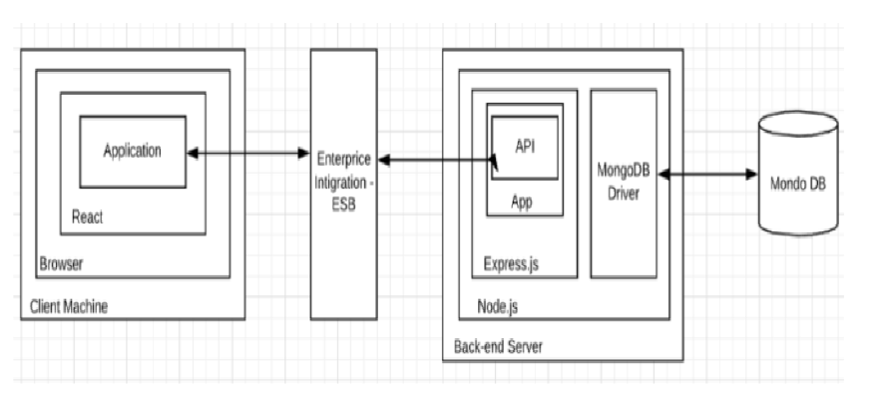

**Fig1: System Architecture**

Designing a system for an Online Railway Reservation System with registration and recognition involves various components. Below is a high-level overview of the system architecture**.**

* + 1. **Registration**:

**1**.User Registration and Authentication:

* Users need to register with the system by providing essential information (name, contact details, etc.).
* Implement a secure authentication mechanism, such as email verification or SMS verification, to ensure the security of user accounts.
* Utilize password hashing to store passwords securely.

2.User Profile Management:

* Allow users to manage their profiles, update personal information, and change passwords.
* Include features for users to add or manage their preferred payment methods.

3.Security Measures:

* Implement SSL/TLS for secure data transfer between the client and the server.
* Use CAPTCHA or other anti-bot mechanisms during the registration process to prevent automated attacks.

4. Logging and Auditing:

* Implement logging to record user activities and system events.
* Set up auditing mechanisms to monitor and track any suspicious or unauthorized activities.   
  + 1. **Recognition:**

1.Biometric Database:

* Store biometric data securely in a dedicated database.
* Ensure compliance with privacy regulations and encryption standards.

2.Ticket Booking System:

* Implement seat availability checks and reservation confirmation as outline din the previous design.

3.Train Schedule Management:

* Admins manage the train schedule, add new trains, update existing schedules
* Handling cancellations as outlined in the schedule.

4.Reporting and Analytics:

* Generate reports on recognition system performance, successful authentications, and any issues.
* Use analytics to optimize the recognition system’s performance.

5.Feedback and support:

* Offer customer support channels to address user queries and problems.
* Include a feedback mechanism for users to provide valuable suggestions or report issues related to the recognition system=
  1. **Modules Used:**

1. Login module: User can login to the website by entering email id and password. User is the only authorized person to access this module for booking purpose. If user wants to create an account by clicking join now button which is at the below.
2. Registration Module: In registration module user can manage his profile. User needs to enter all the required details i.e. full name, mobile, email, password. After entering all the details and on hitting register button, user is successfully registered into the website. By clicking sign in user redirects to login page.
3. Home Module: In home page following submodules are displayed.

* Contact Us
* Sign in
* Join now

1. Reservations Module: In this module the user/customer can see his/her reservation history. If user want to cancel the ticket then he/she can click on the cancel button which is available at the bottom.
2. Payment Module: In this module after entering the booking details we provide the payment options like via credit/debit cards or phone. After payment is done a popup is shown at the bottom saying your payment is successful.

**3.3 Data Flow Diagram**

A Data Flow Diagram (DFD) is a graphical representation of the "flow" of data through an information system, modeling its process aspects. A DFD is often used as a preliminary step to create an overview of the system, which can later be elaborated. DFDs can also be used for the visualization of data processing (structured design).

* + 1. **DFD Level 0:**

The level 0 DFD or a context model represents the entire software element as a single bubble with input and output data indicated by incoming and outgoing arrows, respectively.

In level 0 diagram shown below, the passenger fills either the reservation or cancellation form as input. He gets the ticket as the output and the report is sent to the administration.

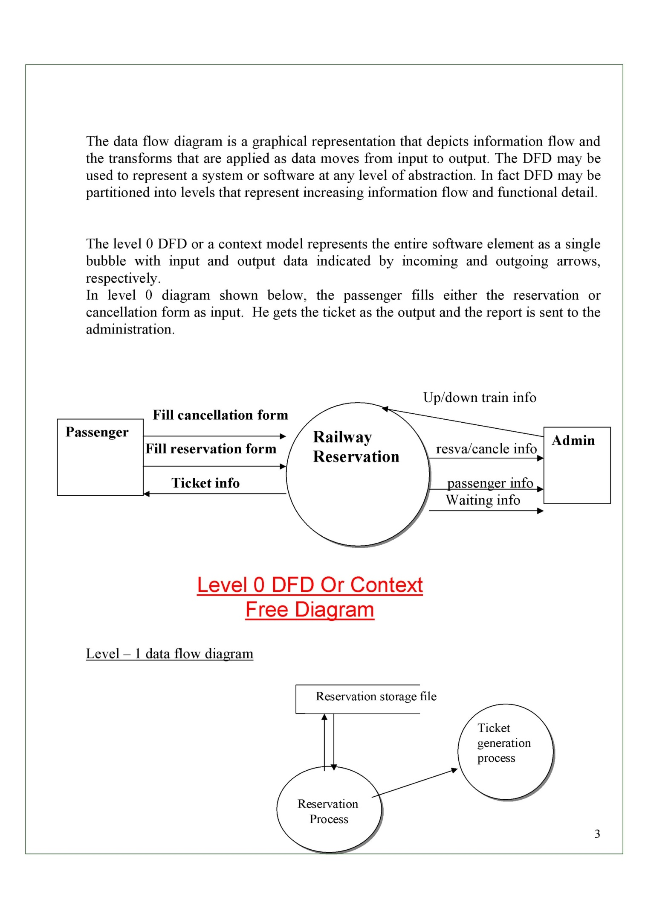

**Fig 2: DFD Level 0**

* + 1. **DFD Level 1:**

A level 1 DFD is the furthur refinement of level 0 DFD showing greater details and functionalities. In this, the single bubble of level 0 DFD is refined furthur . Each of the processes depicted at level 1 is a subfunction of the overall system depicted in the context model.

As shown in the DFD above, the passenger either enquires about the trains or goes directly for the reservation or the cancellation processes as a result of which he gets the ticket generated. The reports are then sent to the administration

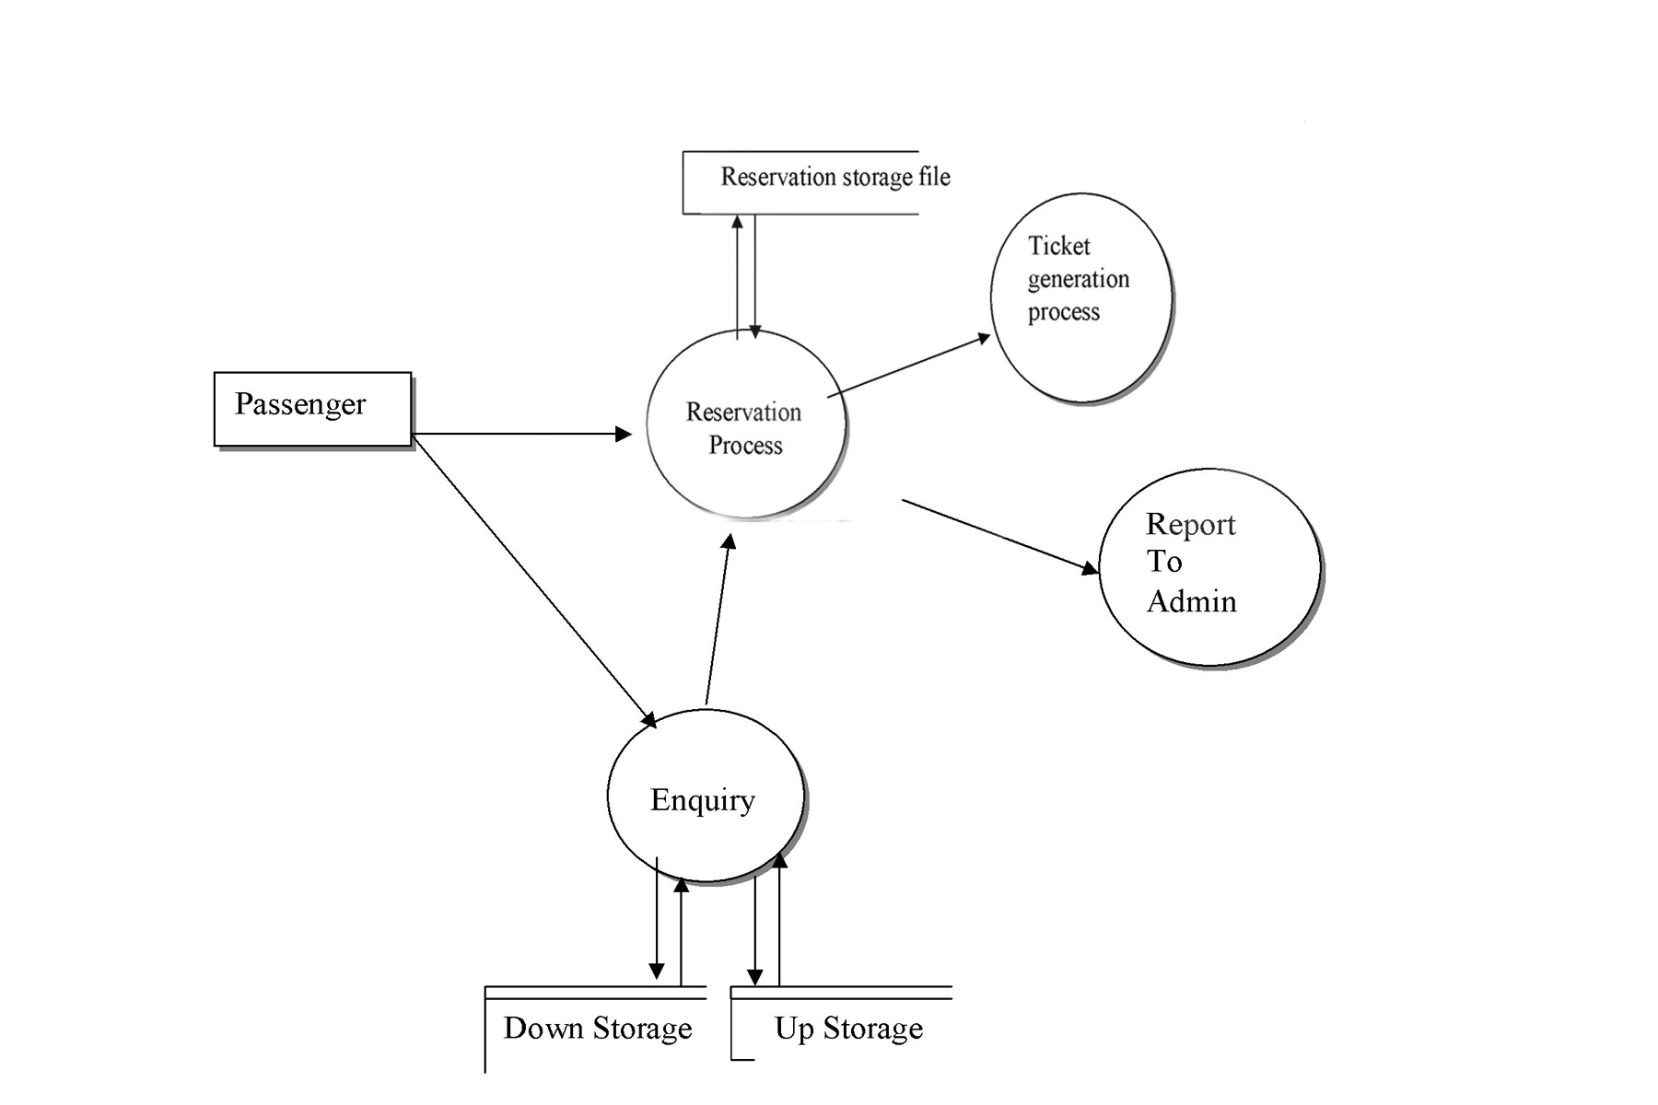

**Fig 3: DFD level 1**

* + 1. **Level 2 DFD:**

The level 2 DFD is the further refinement of the level 1 DFD. As shown in the DFD above the passenger has many options like he can directly go to the reservation counter or can first inquire and then go to the reservation counter or he can just inquire and return back. If the passenger wants reservation then the seats are checked for availability and if the seats are available the confirmation ticket is generated other wise he is asked for waiting and waiting ticket is generated if he wants. If the user wants tickets to be cancelled he is given the cancellation ticket and the reports of all the transactions are sent to the administrator.

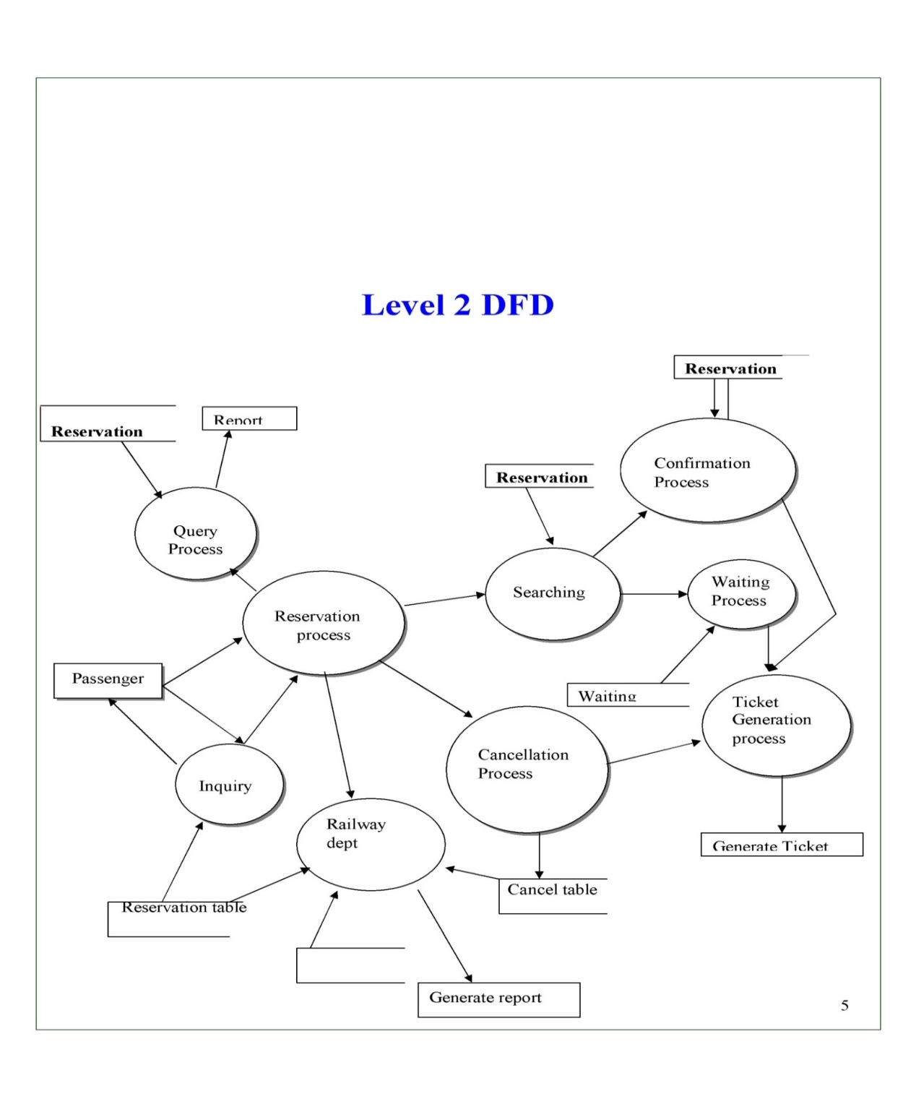

**Fig 4: DFD level 2**

3.4 **Advantages**

1. Convenience for Users: Users can conveniently check train schedules, availability, and make reservations from the comfort of their homes using a computer or a mobile device**.**
2. 24/7 Accessibility: The system is accessible 24/7, allowing users to make bookings and check information at any time, overcoming the limitations of traditional ticket counters' operating hours.
3. Real-Time Information**:** Provides real-time information on seat availability, train schedules, and updates, helping users make informed decisions.
4. Reduced Queues and Waiting Time: Eliminates the need for users to stand in long queues at railway stations, reducing waiting time and enhancing the overall user experience.
5. Flexible Booking Options: Users can choose and book specific train routes, classes, and seat preferences according to their preferences and requirements.
6. Online Payment Integration: Integration with online payment gateways facilitates secure and convenient financial transactions, eliminating the need for users to carry cash.
7. Automated Ticket Generation: Generates electronic tickets automatically, streamlining the booking process and reducing the reliance on physical paper tickets.
8. User Profiles and History: Allows users to create profiles, manage personal information, and view booking history, providing a personalized experience.

**3.5 Requirement Specification**

**3.5.1 Hardware Requirements:**

For the hardware requirements the SRS specifies the logical characteristics of each interface bow the software product and the hardware components. It specifies the hardware requirements like memory restrictions, cache size, the processor, RAM size etc... those are required for the software to run.

1. Minimum Hardware Requirements: Processor Pentium III Hard disk drive 40 GB RAM 128 MB, Cache 512 kb
2. Preferred Hardware Requirements: Processor Pentium IV, Hard disk drive 80 GB, RAM 256 MB, Cache 512 kb

**3.5.2 Software Requirements:**

Any window based operating system with DOS support are primary requirements for software development. Windows XP, FrontPage and dumps are required. The systems must be connected via LAN and connection to internet is mandatory.

**DATA TABLE:**

|  |  |  |  |
| --- | --- | --- | --- |
| **S.NO.** | **Field name** | **Data type** | **Description** |
| **1** | User Name | Text | Store user name for checking correct username |
| **2** | Password | Text/Number | Store password for checking username |

Login Table:

Table 1: Login Table

|  |  |  |
| --- | --- | --- |
| **S.no** | **Field name** | **Data type** |
| 1 | Class | Text |
| 2 | Name | Text |
| 3 | Age | Number |
| 4 | Gender | Text |
| 5 | Date | Number |

RAILWAY RESERVATION RECORD TABLE:

**Table 2: Railway Reservation T**

**CHAPTER 4**

**Implementation and Result**

**CHAPTER 4**

**Implementation and Result**

**Login Form code:**

Private Sub Command1_Click ()

If username.Text = "" And password.Text = "" Then

MsgBox "please enter Username And Password"

Else

If username.Text = "admin" Then

If password.Text = "login" Then

MsgBox "successfully login"

username.Text = ""

password.Text = ""

Form3.Show

Else

If password.Text = "" Then

MsgBox "Please enter your Password"

Else

MsgBox "Wrong Password"

password.Text = ""

username.Text = ""

End If

End If

Else

If password.Text = "123" Then

MsgBox "username is wrong"

username.Text = ""

password.Text = ""

Else

MsgBox "wrong username And password"

username.Text = ""

password.Text = ""

End If

End If

End If

End Sub

**Search Form Code:**

Private Sub Combo1_Click()

Adodc1.Refresh

Adodc1.Recordset.Find "Train_No =" & Combo1.Text, 0, adSearchForward

If Adodc1.Recordset.EOF = True Then

MsgBox ("Train not Available")

End If

End Sub

Private Sub Command1_Click()

Temp1 = Combo1.Text

Unload Me

Load Form2

Form2.Show

End Sub

Private Sub Command2_Click()

Unload Me

End Sub

**CHAPTER 5**

**CONCLUSIONCHAPTER 5**

**CONCLUSION**

Practical Training is a very important part of the curriculum as it strengthens the concepts and enhances knowledge about the practical implementation of all the theory concepts, we have learnt so far in different subjects. This project is used to keep a track on reserving the seat to the passenger. It helps managing the system very efficiently and conveniently. Finally, this gives us a lot of mental satisfaction that the project we have worked upon is a real time project, which will be installed at the customer site after some more session of regress testing.

Although the project work has been done in a detailed manner but due to the constraint of time, we could not include some more features we wanted to in these 2 modules of implementation. We left these features as a part of the future development. As soon as we'll get time we'll try to add them to my project.

**REFERENCES**

1. Ming-Hsuan Yang, David J. Kriegman, Narendra Ahuja, “Detecting Faces in Images: A Survey”, IEEE Transactions on Pattern Analysis and Machine Intelligence, Volume. 24, No. 1, 2002.

**APPENDIX**